Lab 3 - Vlookup Exercises

**Q1. Use VLOOKUP to find the product names for each ProductID in the Orders worksheet.**

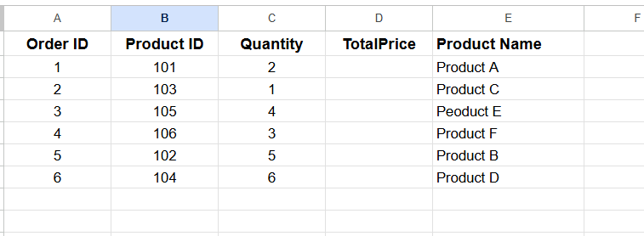

**Q2. Use VLOOKUP to find the price for each ProductID in the Orders worksheet, then calculate the TotalPrice by multiplying the Quantity by the Product Price.**

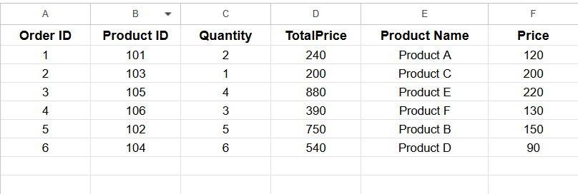

**Q3. Use VLOOKUP to check if there are any ProductIDs in the Orders worksheet that do not exist in the Products worksheet.**

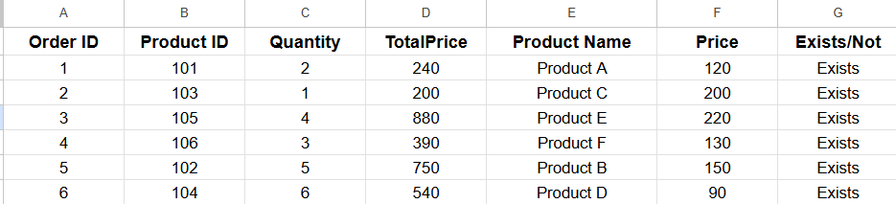

**Q4. Assume a discount of 10% is given on all products. Use VLOOKUP to find the original price and then calculate the discounted price.**

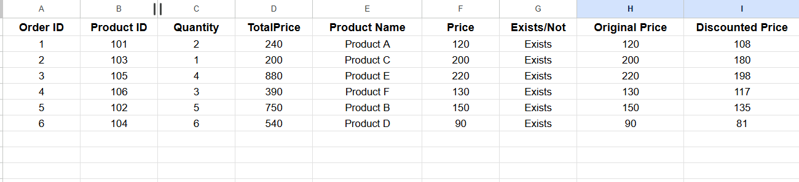

**Q5. Use VLOOKUP to find the price for each ProductID and then calculate the order value. Find the maximum order value from the list.**

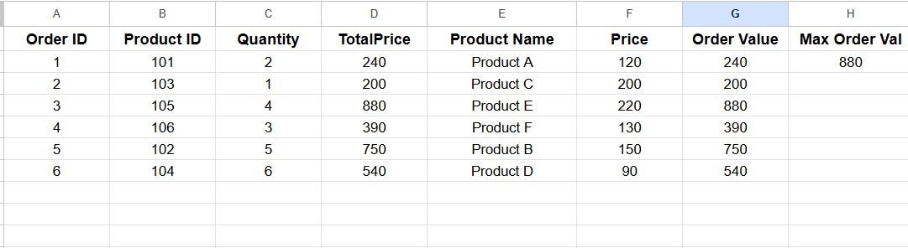

**Q6. Use VLOOKUP to find out which products from the Products worksheet have not been ordered.**

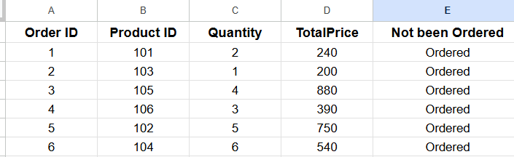

**Q7. Use VLOOKUP to find the Product name and summarize the total quantity sold for each product.**

